Scenario 1: Student Academic Performance Dashboard

CODING:
library(ggplot2)
students <- read.csv("C:/Users/senth/OneDrive/Documents/Data Handeling and Visualization/students.csv")
ggplot(students,
aes(x = Attendance,
y = Internal_Marks,
color = Department)) +
geom_point(size = 4) +
labs(
title = "Student Academic Performance Dashboard",
x = "Attendance (%)",
y = "Internal Marks",
color = "Department"
) +
theme_minimal()

OUTPUT:
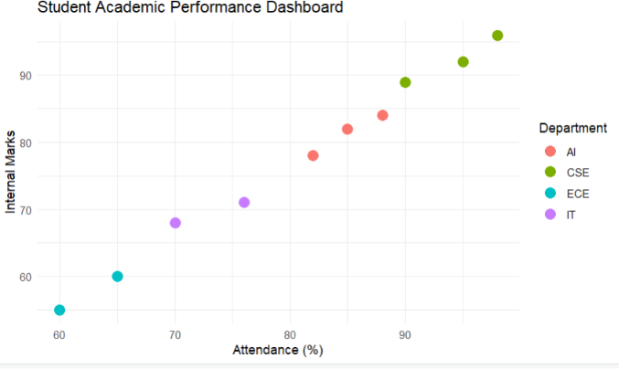

Scenario 2: Electric Vehicle Market Analysis
CODING:
library(ggplot2)

ev <- read.csv("C:/Users/senth/OneDrive/Documents/Data Handeling and Visualization/ev.csv")

ggplot(ev,
aes(x = Battery_Capacity,
y = Price,
size = Driving_Range,
color = Manufacturer)) +
geom_point(alpha = 0.8) +
labs(
title = "Electric Vehicle Market Analysis",
x = "Battery Capacity (kWh)",
y = "Price",
size = "Driving Range",
color = "Manufacturer"
) +
theme_minimal()

OUTPUT:
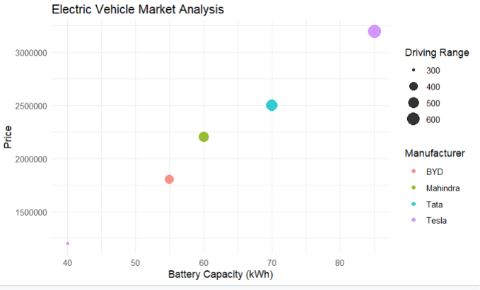

Scenario 3: Hospital Patient Admission Analysis
CODING:
library(ggplot2)
hospital <- read.csv("C:/Users/senth/OneDrive/Documents/Data Handeling and Visualization/hospital.csv")

ggplot(hospital,
aes(x = Department,
y = Number_of_Patients,
fill = Department)) +
geom_bar(stat = "identity") +
geom_text(aes(label = Average_Treatment_Cost),
vjust = -0.4,
size = 5) +
labs(
title = "Hospital Patient Admission Analysis",
x = "Department",
y = "Number of Patients"
) +
theme_minimal()

OUTPUT:
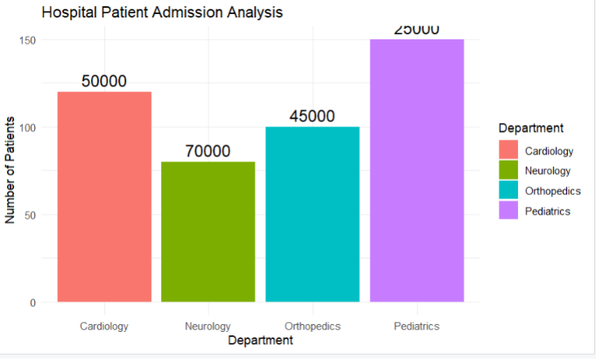

Scenario 4: Weather Monitoring System
CODING:
library(ggplot2)
weather <- read.csv("C:/Users/senth/OneDrive/Documents/Data Handeling and Visualization/weather.csv")
ggplot(weather,
aes(x = Date,
y = Temperature,
color = City,
linetype = City,
group = City)) +
geom_line(size = 1.2) +
labs(
title = "Weather Monitoring System",
x = "Date",
y = "Temperature"
) +
theme_minimal()

OUTPUT:
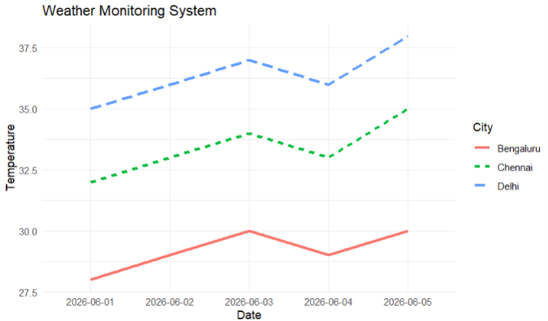

Scenario 5: Supermarket Sales Analysis
CODING:
library(ggplot2)

sales <- read.csv("C:/Users/senth/OneDrive/Documents/Data Handeling and Visualization/sales.csv")

ggplot(sales,
aes(x = Product_Category,
y = Sales_Amount,
fill = Branch)) +
geom_bar(stat = "identity",
position = "dodge") +
labs(
title = "Supermarket Sales Analysis",
x = "Product Category",
y = "Sales Amount"
) +
theme_minimal()

OUTPUT:
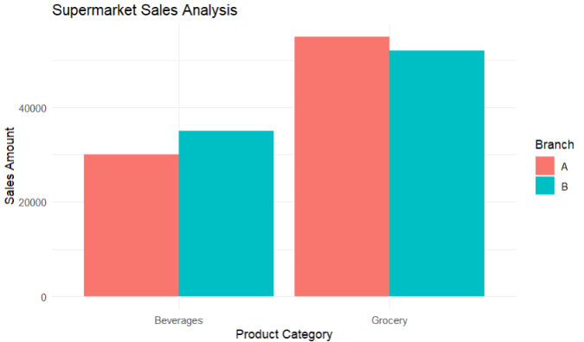

Scenario 6: Employee Salary Distribution
library(ggplot2)

employee <- read.csv("C:/Users/senth/OneDrive/Documents/Data Handeling and Visualization/employee.csv")

ggplot(employee,
aes(x = Salary)) +
geom_histogram(
binwidth = 5000,
fill = "skyblue",
color = "black"
) +
labs(
title = "Employee Salary Distribution",
x = "Salary",
y = "Frequency"
) +
theme_minimal()

Scenario 7: Smartphone Market Comparison
OUTPUT:
library(ggplot2)
phone <- read.csv("C:/Users/senth/OneDrive/Documents/Data Handeling and Visualization/smartphone.csv")

ggplot(phone,
aes(x = RAM,
y = Price,
shape = Brand,
size = Storage,
color = Processor_Speed)) +
geom_point() +
labs(
title = "Smartphone Market Comparison",
x = "RAM (GB)",
y = "Price"
) +
theme_minimal()

OUTPUT:
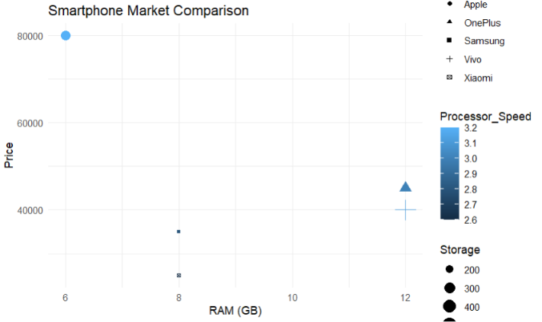

Scenario 8: Online Movie Rating Analysis
CODING:
library(ggplot2)
movies <- read.csv("C:/Users/senth/OneDrive/Documents/Data Handeling and Visualization/movies.csv")
head(movies)
ggplot(movies,
aes(x = factor(Release_Year),
y = Genre,
fill = Average_Rating)) +
geom_tile(color = "white") +
scale_fill_gradient(
low = "yellow",
high = "darkgreen"
) +
labs(
title = "Online Movie Rating Analysis",
subtitle = "Average Ratings by Genre and Release Year",
x = "Release Year",
y = "Movie Genre",
fill = "Average Rating"
) +
theme_minimal() +
theme(
plot.title = element_text(face = "bold", size = 16),
axis.title = element_text(size = 12),
legend.title = element_text(size = 11)
)

CODING:
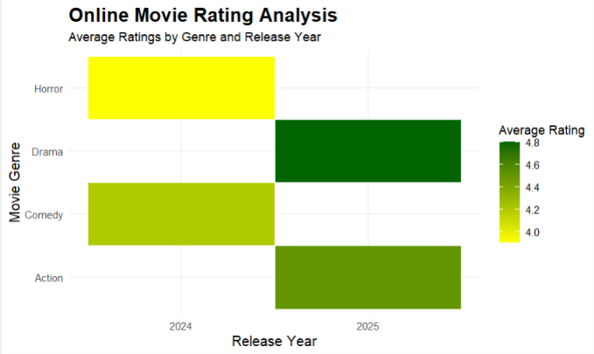

Scenario 9: COVID-19 State-wise Analysis
CODING:

library(ggplot2)

covid <- read.csv("C:/Users/senth/OneDrive/Documents/Data Handeling and Visualization/covid.csv")

ggplot(covid,
aes(x = 1,
y = State,
fill = Active_Cases)) +
geom_tile() +
labs(
title = "COVID-19 State-wise Analysis",
y = "State",
fill = "Active Cases"
) +
theme_minimal() +
theme(
axis.title.x = element_blank(),
axis.text.x = element_blank(),
axis.ticks.x = element_blank()
)

OUTPUT:
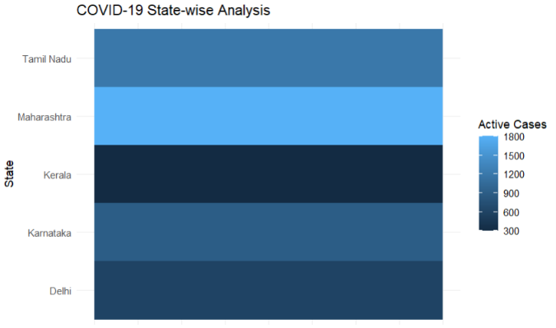

Scenario 10: Iris Flower Classification
CODING:
library(ggplot2)

ggplot(iris,
aes(x = Sepal.Length,
y = Petal.Length,
color = Species,
shape = Species,
size = Sepal.Width)) +
geom_point() +
labs(
title = "Iris Flower Classification",
x = "Sepal Length",
y = "Petal Length"
) +
theme_minimal()

OUTPUT:
